**State chart Diagram**

A state chart diagram shows the behavior of classes in response to external stimuli. This diagram models the dynamic flow of control from state to state within a system.

**Basic State chart Diagram Symbols and Notations**

**States**

States represent situations during the life of an object. You can easily illustrate a state in Smart Draw by using a rectangle with rounded corners.

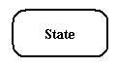

**Transition**

A solid arrow represents the path between different states of an object. Label the transition with the event that triggered it and the action that results from it.

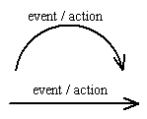

**Initial State**

A filled circle followed by an arrow represents the object's initial state.

Initial State

**Final State**

An arrow pointing to a filled circle nested inside another circle represents the object's final state.

Final State

**Synchronization and Splitting of Control**

A short heavy bar with two transitions entering it represents a synchronization of control. A short heavy bar with two transitions leaving it represents a splitting of control that creates multiple states.

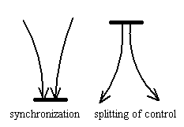

Server State Chart Diagram



Fig: Server State Chart diagram



User State Chart diagram